Up to 2.5GHz Lightning Protector

Model Number: CH-LP-NMF-2.45GHz

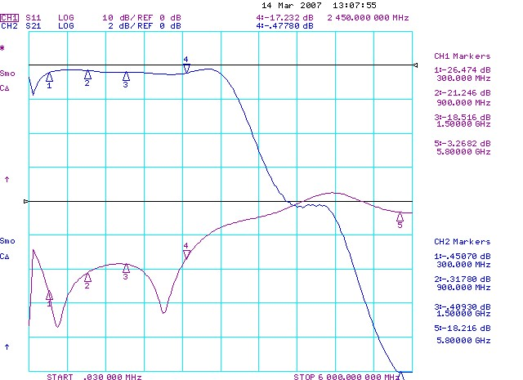

Model Number: CH-LP-NMF-6GHz

